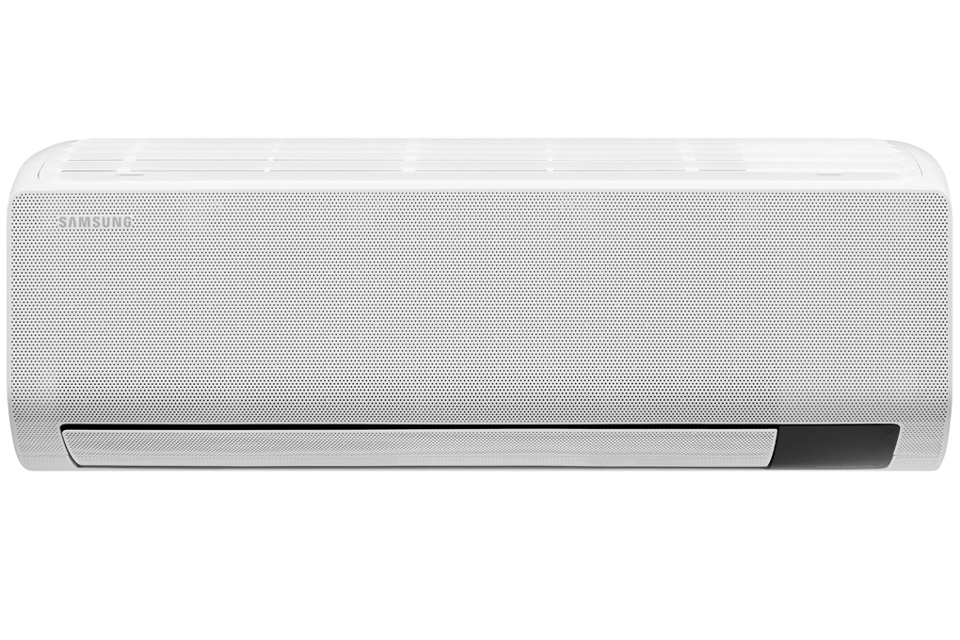

**13,390,000 VND**

(-6%)No copper pipes and supplies will be given away.Delivery only, no installation.

**Technical specifications Samsung Wind-Free Inverter 1.5 HP AR13TYGCDWKNSV air conditioner**

* Machine Type:

1 way (cooling only) With Inverter

* Cooling capacity:

1.5 HP - 12,000 BTU

* Effective cooling range:

From 15 - 20m² (from 40 to 60 m³)

* Dust filter, antibacterial, deodorant:

Tri Care Filter filter dust, anti-mold, antibacterial Easy Filter coarse filter

* Power saving technology:

EcoDigital Inverter Boost

* Rapid cooling:

Have

* Utilities:

Triple Protector Plus for optimal protection for durable performance Wind-Free mode for cool air comfort Fan Only mode - cooling only, no cooling Durafin anti-corrosion coated heatsink Island 4-way wind helps the cold air spread evenly Dehumidification function Night sleep mode to avoid frostbite Timer to turn on and off Automatically restarts when there is power Screen displays the temperature on the indoor unit Self-cleaning function

* Power consumption:

1.25 kW/h 5 stars (Energy efficiency 4.9)

* Cooler:

Length 82 cm - Height 30.5 cm - Thickness 21.5 cm - Weight 9.2 kg

* Outdoor:

Length 73 cm - Height 47.5 cm - Thickness 27.7 cm - Weight 19.4 kg

Introducing the company 

- A brand from Korea, founded in 1938.  
- Samsung is a multi-industry corporation, with a high level of brand recognition on a global scale.  
- Samsung's products range from mobile devices, home appliances, electronics,...  
- With the strength of being the brand of a global corporation, the quality of products always reaches the highest level of perfection. , good warranty should be trusted by customers around the world.

**Cools quickly without cold wind blowing directly thanks to  WindFree™  23000-hole**[**technology on the front of the machine**](https://www.dienmayxanh.com/kinh-nghiem-hay/wind-free-cong-nghe-lam-lanh-cua-tuong-lai-1068729)

[Samsung Wind-Free Inverter 1.5 HP AR13TYGCDWKNSV air conditioner](https://www.dienmayxanh.com/may-lanh/samsung-ar13tygcdwknsv) , in addition to fast cooling ability, also has the option of WindFree™ cooling mode **without cold wind blowing directly.**

Just one click to select WindFree™ mode on the remote and the room will **quickly reach the optimal cool temperature** or **gently blow cold air through 23,000 small holes** , creating a gentle breeze, limiting direct wind. while still maintaining the user's desired temperature.

**Filters 99% of viruses, bacteria, fine dust and allergens with**[**Tri-Care filter**](https://www.dienmayxanh.com/kinh-nghiem-hay/ly-do-chon-mua-may-lanh-samsung-wind-free-hoan-hao-1157372#easy-filter)

Certified by international organizations ITEA and Intertek, the Tri-Care 3-layer filter includes high-density filter layers with Zeolite coating to help filter fine dust particles **, eliminating 99% of viruses, bacteria and agents. cause allergies** . Thanks to that, you can enjoy the cleanest air possible, protecting your health.

**Super energy saving up to 77% with Digital Inverter Boost motor**

Digital Inverter Boost technology will help save energy up to **77%** (when combined with WindFree™ cooling technology) and **maintain stable desired temperature** .

Besides, the Neodymium magnet and Twin Tube Muffler help  **the machine operate quietly, smoothly and last a long time with a 10-year** engine warranty period  .

**Easily clean the filter yourself with the Easy Filter Plus**

Samsung air conditioners are equipped with an Easy Filter Plus filter located at the top of the machine. You can  **easily remove and install the filter as well as clean it under the tap** , helping the machine operate optimally.

The thick mesh keeps the heat exchanger clean, while the anti-bacterial coating protects you from dangerous airborne contaminants.

**Save cleaning time thanks to**[**the Auto Clean self-cleaning feature**](https://www.dienmayxanh.com/kinh-nghiem-hay/chuc-nang-tu-dong-lam-sach-tren-may-lanh-1080148)

Thanks to the self-cleaning function,  [Samsung air conditioners](https://www.dienmayxanh.com/may-lanh-samsung)  have the ability to automatically dry the heat exchanger after shutting down through 3 strict steps. After blowing air for 10 to 30 minutes, **moisture will be removed, preventing bacteria and odors** , providing optimal cooling efficiency and extending the machine's usage time.

**Ultimate protection for durable performance with Triple Protector Plus technology**

Triple Protector Plus technology with 3 protection effects  **for the compressor, motor and heat exchanger** will prevent damage due to pressure surges or current fluctuations without the need for a separate voltage stabilizer. The anti-corrosion coating will effectively protect the heat exchanger and can operate in all harsh weather conditions.

**Optimal heat exchanger protection with**[**DuraFin™ anti-corrosion technology**](https://www.dienmayxanh.com/kinh-nghiem-hay/he-thong-tan-nhiet-chong-an-mon-durafin-la-gi-1115568)

[The air conditioner](https://www.dienmayxanh.com/may-lanh)  uses DuraFin™ anti-corrosion technology with thicker and denser design materials and improved coatings that will help **prevent corrosion from** occurring, thereby enhancing the performance of the heat exchanger. .

**Use environmentally friendly**[**R32**](https://www.dienmayxanh.com/kinh-nghiem-hay/cac-loai-gas-tren-may-lanh-588213#r32)**refrigerant**

Samsung Inverter air conditioners use the currently popular R32 refrigerant, which will **limit negative impacts on the atmosphere** , thereby **preventing global warming and protecting the environment**  more effectively than R22 refrigerant. or regular R410A.

**Capacity 1.5 HP, suitable for rooms with an area of ​​15 - 20 m2**

Samsung Wind-Free Inverter AR13TYGCDWKNSV air conditioner has a cooling capacity of 1.5 HP equivalent to 12000 BTU, this air conditioner will be a suitable choice for rooms with an area of ​​15 - 20 m2.

In general, the Samsung Wind-Free Inverter 1.5 HP AR13TYGCDWKNSV air conditioner is a suitable choice for families with a room area of ​​15 - 20 m2. In addition to being equipped with many ideal cooling technologies, this Samsung air conditioner also helps users use electricity effectively throughout the machine's operating time.